**BAX 442 Advanced Statistics: Homework 2**

**By Nandini Basu, Alayna C. Myrick, Ana Parra Vera, Allyson Tsuji**

**1. Build a positioning map for the car brands, where the number of attributes exceeds the number of brands (p > N)**

Hence from the positioning map, we can see where Infinity stands compared to its competitors and also the iso-preference line which is at an angle of -85.65°.

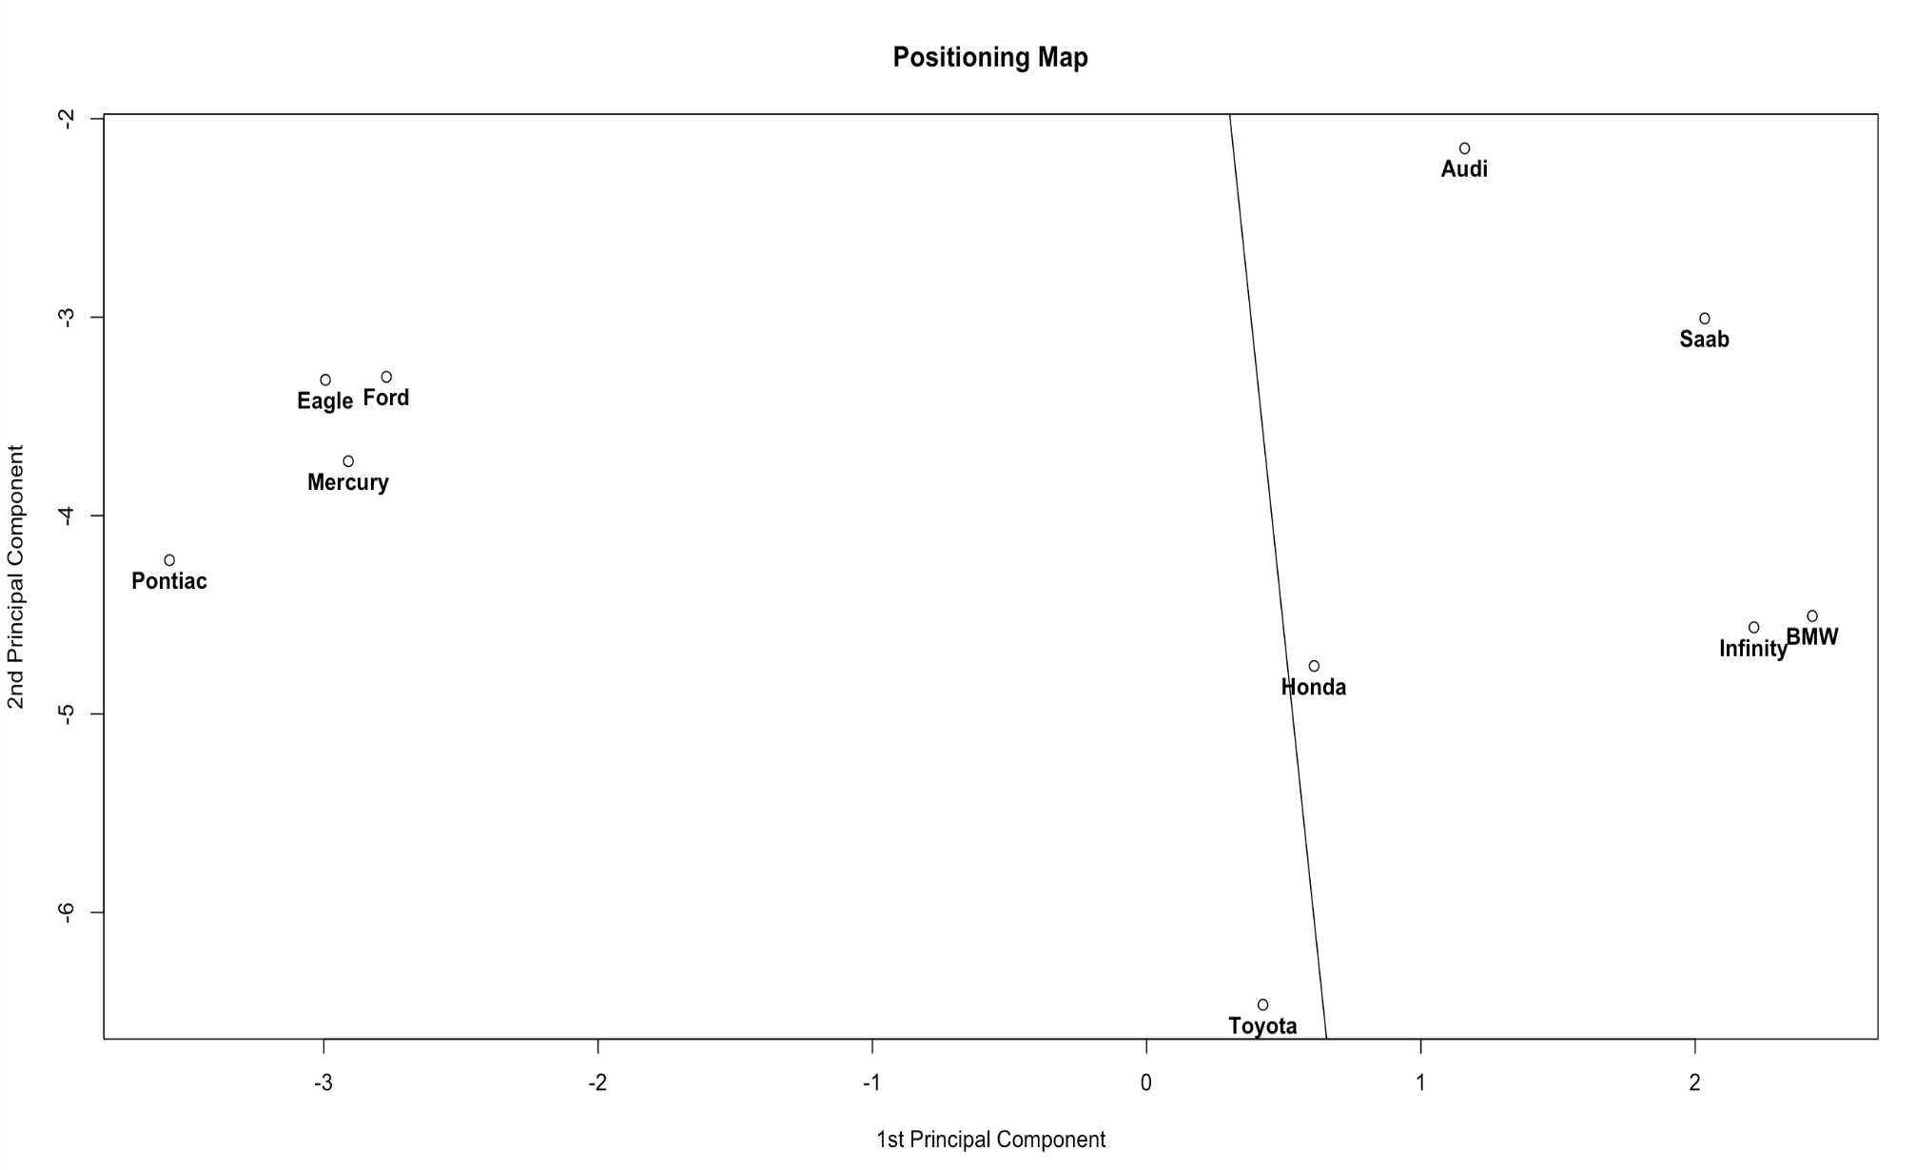

**2. Assign names to the factors z1 and z2 based on the dominant weights (the values of eigenvector > 0.3). Use the names to label the axes of the brand map.**

We consider the weights that are more than 0.3 in magnitude to be the dominant traits. For PC1 these are attractive, quiet, poorly built(negative correlation), prestige and successful which can all be traits associated with **premium or status-symbol cars**. Thus if you move towards the right along PC1 you increase the attributes attractiveness, quietness, prestige and success but decrease the poor build. Similarly, for PC2 the dominant traits are unreliable, sporty(negative correlation), roomy and easily serviceable(negative correlation). Thus when you move upwards along PC2 you increase unreliability and roomy-ness and decrease sporty-ness and serviceability. This car is probably a **spacious, no-frills attached car**.

**3. Explain iso-preference line and its difference from the regression line**

For a specific market and a given set of attributes, the iso-preference line is the line along which consumers’ preferences for a certain product remain the same. This is different from the regression line which measures the response in one variable with respect to change in another variable.

**4. Explain why the ideal vector indicates the direction of increasing preferences**

Since the iso-preference line is the line along which the preferences remain the same, the ideal vector, which is orthogonal to the iso-preference line, gives the direction in which consumer preferences increase.

**5. Compute the orientation of the ideal vector. Place an arrow at the origin on z1-z2 plot with 10 brands as points with brand names as labels (you can use Excel).**

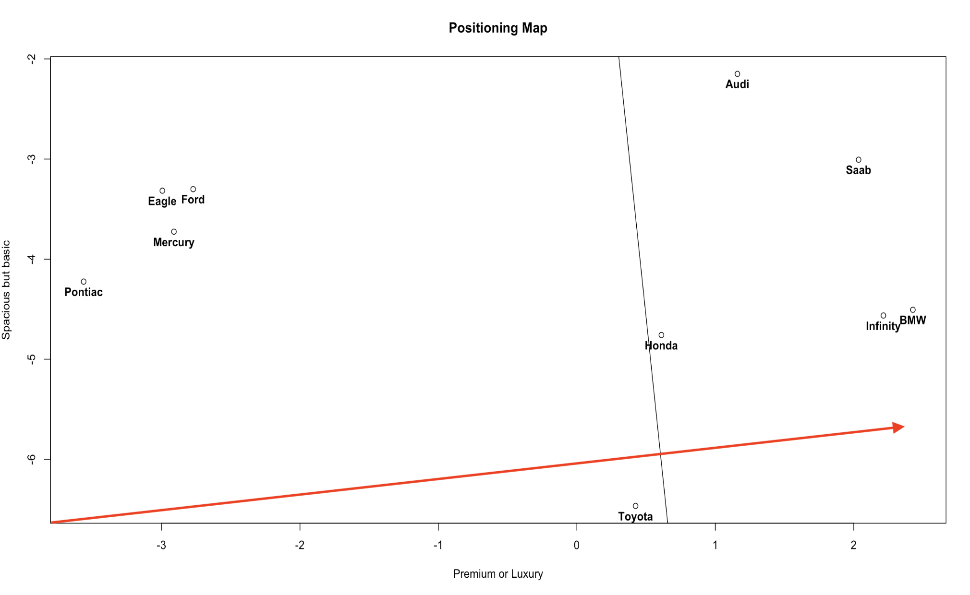

**6. Infinity is the focal brand. Recommend what Infinity should do to improve the car’s design**

To improve their car’s design, Infinity must move towards a space where they have limited competition in order to differentiate their product. They could consider changing their z1 attributes by decreasing or increasing their premium style. Perhaps making their product more premium would increase their consumer demand, or perhaps making their car less premium would allow them to lower costs. However, both of these decisions would also face an additional trade-off - Infinity would likely face competition with Honda or BMW. Infinity could also attempt to increase the spaciousness of their car, a main attribute of the z2 principal component. However, this move would place them closer to competitors like Saab and Audi. Instead, Infinity could look to lower their z2 and improve their car’s design by increasing its serviceability, a major attribute of the z2 component. Infinity would, therefore, differentiate itself from competitors while providing an improved feature for their car.

**7. Find the 90% confidence interval for the angle of the ideal vector? Think about how to do it --we will discuss and cover it in the next class.**

We could use the bootstrap to find the confidence interval for the angle of the ideal vector. To do so, we took 1000 draws from our sample and found the z1 and z2 components for each draw. We then found the angles for the ideal vectors for each of the component pairs and sorted those angles from smallest to largest. The 90% confidence interval was from the 50th angle to the 90th angle. Based on this method, the 90% confidence interval that we found for the angle of the ideal vector was [-29.16, 26.65].